FULL-TEXT PAPER PREPARATION GUIDE FOR THE INTERNATIONAL CONFERENCE ON CHEMICAL TECHNOLOGY [CALIBRI BOLD FONT, 10 POINT SIZE, CAPITAL LETTERS, LEFT ALINGMENT]

**Engineer M.1**, Researcher M.1,2 [Calibri 10 point size, left alignment, **main author underlined and bold**]

1The Company, Our Street 7, 879 49, Prague 6 [Calibri font, italic, 10 point size, left alignment]  
2Institution of the Chemical Research, Chemical Street 5, 111 99, Benzene City [Calibri font, italic, 10 point size, left alignment]

xxxxx@mmm.cz [corresponding address, Calibri font, italic, 10 point size, left alignment, new line]

The full-text must be prepared on a sheet of A4 size (297x210 mm) with all margins equal to 2.5 cm. The single spaced text should be typed in Calibri font, 10 point size. The full-text cannot exceed 6 pages. The full-text should be saved in MS Word Document Type (*.doc, *.docx) or Rich Text File (*.rtf). The maximum file size is 5 MB. The name of the file must contain author surname and text „full_text“ (e.g. Engineer_full_text.doc)

The figures and tables should be inserted into the text.

## Abstract

The abstract of your paper should be approximately 150 words. It should be a brief but concise description of your paper and should clearly identify the aims of the work and its unique features.

## Main body

The main body of the paper should contain (but is not limited to):

Introduction

Simulation and/or experiment

Discussion and result analysis

Conclusion

The headings of each section should use font size of 12 point, bold, with 6 and 3 points spacing above and below. The headings of the subsection should use 10 points size, with 6 and 3 points spacing above and below. The text should be typed in 10 point Calibri font with simple spacing. Both the sections and subsections should not be numbered.

The compounds should be numbered in bold (e.g. **VI** or **6**).The references should be numberedwithArabic in superscript1 before punctuation.

The tables should be typed in Calibri 10 point and formatted as Table I (please do not use cross references). Please, be careful about the correct number format. Please avoid using computer format of numbers (e.g. 4.85E-3), the correct format is 4.85 x 10-3.

Table I

Basic specification of carbon composites CHEZACARB®

| Quality parameter | CHEZACARB® | | | | | |
| --- | --- | --- | --- | --- | --- | --- |
| EKO SH  [unit] | EKO S  [unit] x 105 | EKO B | A+ | A | B |
| Spec. surface area (ads. N2), m2g–1 | – | – | min. 800 | 815–1005 | min. 800 | min. 800 |
| Iodine adsorption, mg g–1 | 950–1200 | 950-1200 | 950-1250 | 1010–1140 | 900–1200 | 950–1250 |
| Ash content, % | max. 1.5 | max. 1.7 | max. 1.7 | max. 0.35 | max. 0.9 | max. 1.7 |
| Content sulphur, % | – | – | max. 0.6 | max. 0.23 | max. 0.5 | max. 0.6 |
| Dust contents, % | – | – | max. 20 | max. 5 | max. 15 | max. 20 |

Calibri 10 point font should be used in figures and chemical formulas. The labels of the axis should be typed in Calibri 10 as in example (Figure 3). Please, avoid the computer format of the numbers.



Figure 1. Commentary (legend) [Calibri 10 point]

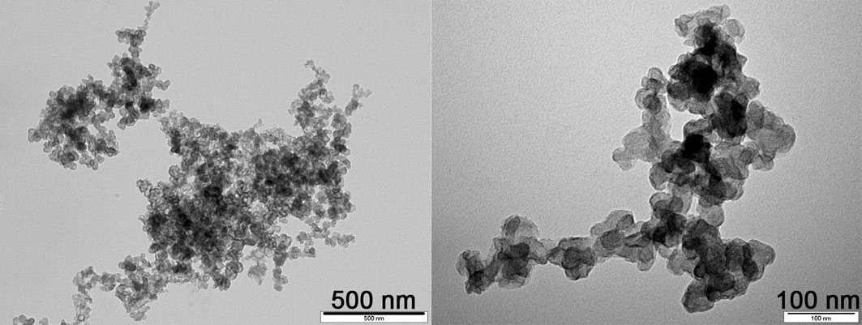

Figure 2. Structure of primary particles Chezacarb®

## C:\Users\Petr\Documents\MATLAB\vzor.emf

Figure 3. Example of the concentration profile of the investigated reaction system.

## Other sections

Add the following sections if applicable:

Acknowledgements

Nomenclature

## Acknowledgement

This work was supported by Ministry of Education, Youth and Sports No.CZ.111/1.1.11/11.1111 [italic, Calibri 10 point.]

## References

References should be summarized at the end of your paper with abbreviations according to the examples below. Please avoid automatic numbering of the references! Cite all the authors, do not use the abbreviation „et al.“.

1. Researcher Z.: Journal abbr., *Volume,* First page (year).

2. Kraus T., Buděšínský M., Závada J.: Carbohydr. Res. *304*, 81 (1997).

3. Čapek P., Veselý M., Hejtmánek V.: Chem. Eng. Sci. *118*, 192 (2014).

4. Waisser K., Peřina M., Kuneš J., Klimešová V., Kaustová J.: Il Farmaco, in press*.*

5. Hajduch M., Šarek J.: Triterpenoid derivatives. PCT Intl. Patent Appl. Publ. WO 0190136.

6. Perera S. D., Shaw B. L., Thornton-Pett M.: J. Chem. Soc., Dalton Trans. *1992*, 1469.

7. Lowestein K. A.: *Silicones. A Story of Research.* Wiley, New York 1979.